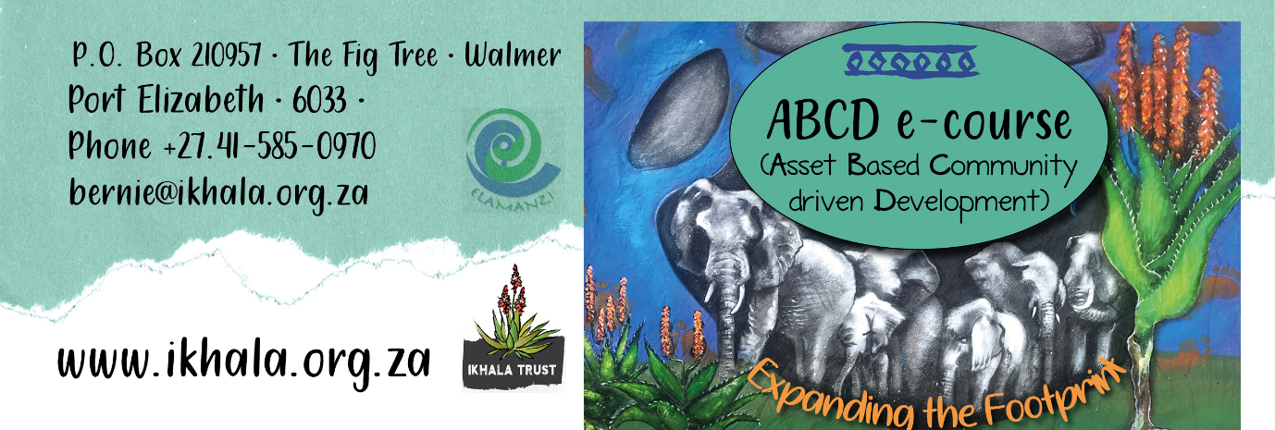

Online Asset-Based Community/Citizen-Driven Development Sessions

Please email your reply to Bernie Dolley at bernie@ikhala.org.za by 12 noon on the 6th May 2022

Name of organisation/ agency/institution
Postal Address:

E-mail address:
Telephone number:
Mobile number:
Full name and surname of participant (s) attending | 1
 | 2
 | 3
Motivation (why are you interested in these sessions)

ABCD & Community-Led Value Chains (CLV) | 31st May 2022 Yes No  09h00 – 12h30
ABCD & Organisational Development (OD) | 24th June 2022 Yes No  09h00 – 12h30
ABCD & Monitoring & Evaluation (M & E) | 20th July 2022 Yes No  09h00 – 12h30

What device will you be using: Laptop, PC, Phone

Date: _________________________________________________

